
COMSATS University Islamabad,
Abbottabad Campus
SOFTWARE REQUIREMENTS SPECIFICATION
(SRS DOCUMENT)
For

Home Ease
Version 1.0
By
Hashir Hamid — CIIT/FA22-BSE-139/ATD
Aman Ullah Khan — CIIT/FA22-BSE-074/ATD
Umar Saeed — CIIT/FA22-BCS-041/ATD
Supervisor
Sir Sumair Khan

Bachelor of Science in Computer Science (2022–2027)

1. Introduction 2
1.1 Purpose 2
1.2 Scope 3
2 Overall Description 4
2.1 Product Perspective 4
2.1 Operating Environment 5
2.2 Design and Implementation Constraints 5
3 Requirement Identifying Technique 6
3.1 Use Case Diagram 7
3.2 Use Case Descriptions 8
4 Specific Requirements 16
4.1 Functional Requirements 16
5 Non Functional Requirements 28
5.1 Usability Requirements 28
5.2 Performance Requirements 28
5.3 Reliability Requirements 29
5.4 Security Requirements 29
5.5 Maintainability Requirements 30
6 Project Gantt Chart 30
7 References 30

Revision History
Name | Date | Reason for changes | Version

Application Evaluation History

Comments (by committee)  *include the ones given at scope time both in doc and presentation | Action Taken

Supervised by
Sumair khan
Signature______________

Introduction
HomeEase is a mobile-based platform designed to connect households with domestic and home-care workers such as maids, cooks, cleaners, nannies, and caregivers. In Pakistan, domestic worker hiring is commonly managed through personal references, neighbors, relatives, or word of mouth. This informal process creates issues related to trust, safety, availability, pricing clarity, communication, and service quality.
HomeEase provides a structured digital solution where household users can search for nearby workers, view profiles, compare services and rates, send booking requests, and submit reviews after completed services. Worker users can create professional profiles, list their services and expected charges, manage availability, receive booking requests, and build a reputation through ratings. Admin users will use a lightweight web dashboard to verify workers and monitor basic platform activity.

Purpose
The purpose of this Software Requirements Specification document is to formally define the functional and non-functional requirements of HomeEase. It establishes a common understanding of the product scope, user roles, system behavior, constraints, interfaces, and quality expectations for the development team, project supervisor, and Final Year Project evaluation committee.
This SRS will guide the 30% analysis/design phase, the 60% implementation phase, and the final 100% thesis and demonstration.

Scope
HomeEase will be developed as a Flutter mobile application for household and worker users, supported by a lightweight React/Vite web dashboard for admin users. The backend, authentication, and database layer will use Supabase and PostgreSQL unless later changed by supervisor instruction.
In scope:
- Mobile app for household and worker users.
- Login page with role choice for household and worker users.
- Household registration and profile setup.
- Worker registration and profile setup.
- Worker service categories and expected pricing.
- Worker availability and verification status.
- Local search using city/area and service category filters.
- Worker list and worker detail screens.
- Booking request creation.
- Worker booking request overview.
- Booking status tracking.
- Basic service agreement/contract generation after worker acceptance.
- Manual payment tracking through EasyPaisa/JazzCash receipt upload and worker confirmation.
- Rating and review after service completion.
- Dispute/report creation linked with bookings, payments, or service issues.
- Notification list for important updates.
- Admin web dashboard for login, worker verification, user overview, booking overview, agreement overview, payment overview, and dispute/report handling.
Out of scope:
- Direct online payment gateway or in-app wallet processing.
- Payroll management.
- Government, NADRA, or police database verification.
- Full legal employment contract enforcement.
- Transportation or logistics for workers.
- Video calling.
- Full real-time chat in the first version.
- Advanced AI recommendations or behavior prediction.
- Household or worker web portals.
- Advanced analytics dashboard.

Overall Description

Product Perspective
HomeEase is a new Final Year Project system and is not an extension of an existing product. It introduces a structured digital workflow for domestic worker discovery, booking, service agreement clarity, manual payment tracking, dispute handling, and review in Pakistan.
The system has three main user roles:
- Household user: searches workers, views profiles, sends booking requests, views agreements, uploads payment receipts, raises disputes, tracks bookings, and submits ratings/reviews.
- Worker user: manages worker profile, services, pricing, payment details, availability, booking requests, service agreements, payment confirmation, disputes, and received ratings.
- Admin user: verifies workers, views users, monitors booking records, reviews agreement/payment records, and handles reported disputes/issues through a web dashboard.
The planned mobile app UI shall contain separate role-based interface flows:
- Splash screen.
- Login screen with household/worker choice.
- Sign-up screen.
- Household search/home screen.
- Worker list screen.
- Worker detail screen.
- Booking request screen.
- Service agreement screen.
- Payment detail and receipt upload screen.
- Dispute/report form screen.
- Worker dashboard screen.

Operating Environment
OE-1: Mobile Application Environment
- Flutter SDK latest stable version.
- Android 10 or above recommended.
- Android emulator or physical Android device for testing.
- Internet connection required for login, registration, search, booking, notifications, and profile updates.
OE-2: Admin Web Dashboard Environment
- React.js with Vite.
- Latest versions of Google Chrome, Microsoft Edge, and Firefox.
- Internet connection required to access Supabase services.
OE-3: Backend and Database Environment
- Supabase cloud project.
- Supabase Authentication.
- PostgreSQL database through Supabase.
- Supabase Flutter client for the mobile app.
- Supabase JavaScript client for the admin dashboard.
OE-4: Development Environment
- Android Studio.
- Visual Studio Code.
- Figma for mockups.
- Draw.io or StarUML for diagrams.
- GitHub for version control.

Design and Implementation Constraints
CO-1: Mobile-first scope
The system shall focus on a Flutter mobile application for household and worker users. Web access for household and worker users is not part of the first release.
CO-2: Lightweight admin dashboard
The admin dashboard shall remain limited to worker verification, users, booking overview, agreement/payment overview, and dispute/report management. It shall not include advanced analytics, payroll, automated payment settlement, or operational automation.
CO-3: Internet dependency
Most system features require internet connectivity because authentication, database reads/writes, booking updates, and notification updates depend on cloud services.
CO-4: Manual/local matching
The first version shall use city/area and service category filtering for local matching. Live GPS can be added later if time allows, but it is not required for the first implementation.
CO-5: Manual payment tracking only
The system shall support manual payment tracking through EasyPaisa/JazzCash receipt upload and worker confirmation. It shall not directly process online transactions, maintain in-app wallets, perform payroll, or provide financial accounting in the first release.
CO-6: Basic service agreement only
The system shall generate a simple booking-based service agreement after worker acceptance. This agreement is used for clarity between household and worker users and shall not be treated as a legally enforceable employment contract in the first version.
CO-7: Limited verification
The system shall support basic admin approval/rejection for worker verification but shall not connect to government or police databases.

Requirement Identifying Technique
The requirements for HomeEase were identified through use case modeling, proposal analysis, competitor analysis, and expected stakeholder feedback.
Use case modeling is appropriate because HomeEase is an interactive application where users perform clear actions such as registering, logging in, creating profiles, searching workers, booking services, responding to bookings, reviewing workers, and approving verification requests.
Requirement sources:
- HomeEase 10% proposal document.
- HomeEase 10% presentation.
- HomeEase v1.5 proposal update.
- Planned Flutter role-based UI/mockup flow.
- Related system analysis of Urban Company, Care.com, and Handy.
- Expected questionnaires/interviews with households and domestic workers.
- Supervisor and committee feedback.

Use Case Diagram
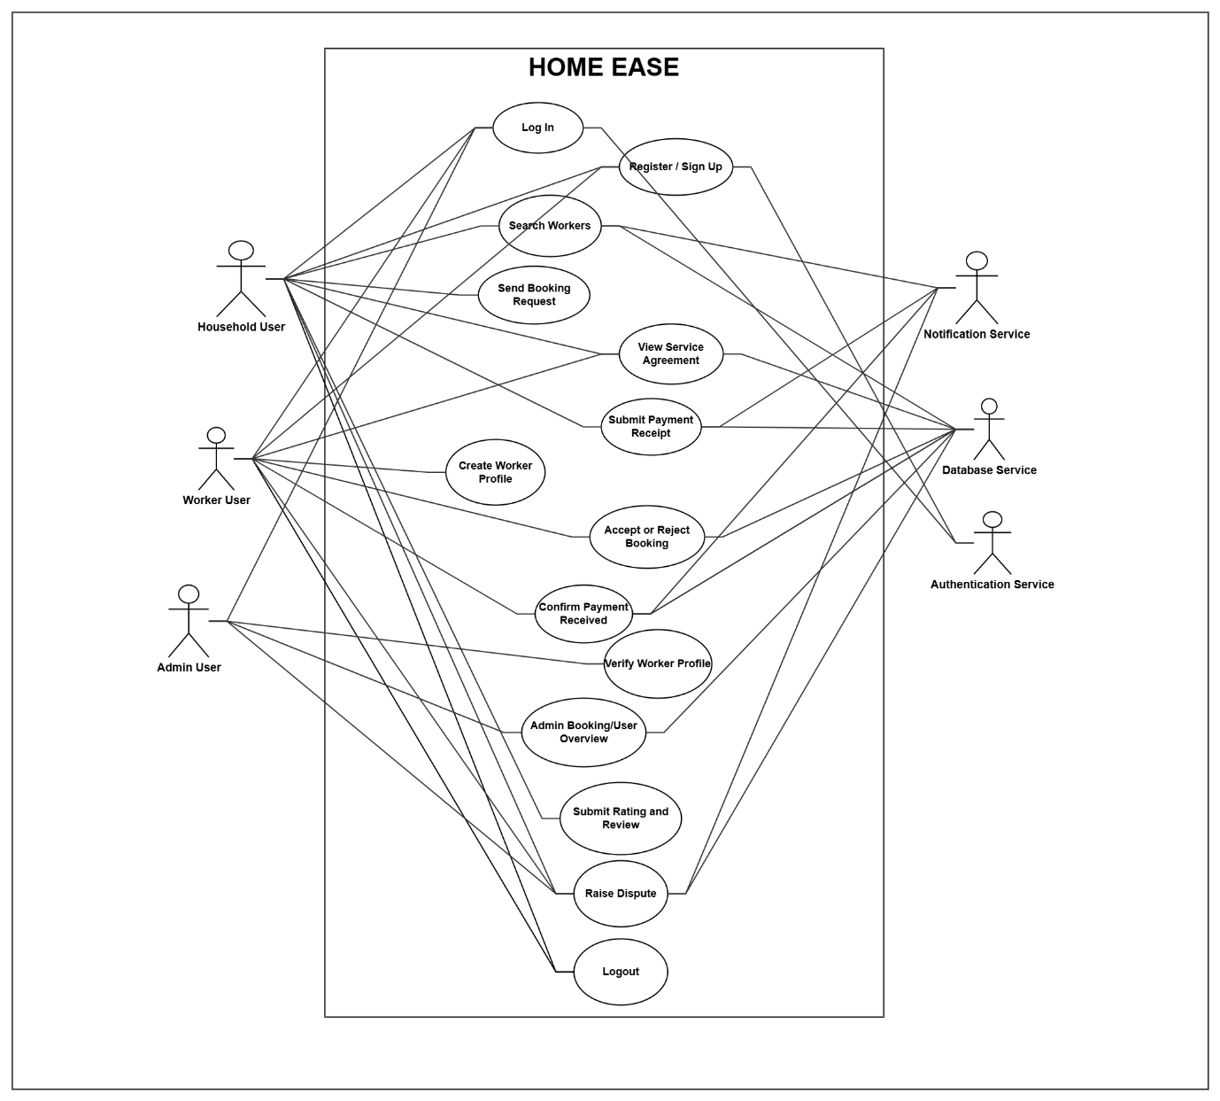

Primary actors
- House hold
- Worker
- Admin
Secondary actors
- Notification Service
- Database Service
- Auth service

Use Case Descriptions

UC-1: Register Account
Field | Description
Use Case ID | UC-1
Use Case Name | Register Account
Primary Actor | Household User, Worker User
Secondary Actor | Authentication Service, Database Service
Description | A new user creates an account and stores their role as household or worker.
Trigger | User selects the sign-up option from the login screen.
Preconditions | User has internet access and the email/phone is not already registered.
Postconditions | User account is created and the role is stored.
Normal Flow | . User opens sign-up screen. 2. User enters name, email, phone, and password. 3. System validates the fields. 4. System creates the account. 5. System creates the initial user profile record. 6. System redirects user to the correct role flow.
Alternative Flows | Invalid input: system displays validation message. Existing account: system asks user to log in or use different credentials. Network failure: system displays connection error.
Business Rules | Email/phone must be unique. Every user must have exactly one role in the first version.
Priority | High

UC-2: Log In
Field | Description
Use Case ID | UC-2
Use Case Name | Log In
Primary Actor | Household User, Worker User, Admin User
Secondary Actor | Authentication Service
Description | Registered users access the system using valid credentials. Household and worker users select their role on the mobile login screen. Admin users log in through the web dashboard.
Trigger | User enters credentials and selects sign in.
Preconditions | User account exists.
Postconditions | User session is created and the correct dashboard is shown.
Normal Flow | . User selects role. 2. User enters credentials. 3. System validates credentials. 4. System checks role and account status. 5. System opens household home, worker dashboard, or admin dashboard.
Alternative Flows | Invalid credentials: system displays error. Wrong role: system blocks access or asks user to select correct role. Inactive account: system displays account status message.
Business Rules | Users can only access features assigned to their role.
Priority | High

UC-3: Create Worker Profile
Field | Description
Use Case ID | UC-3
Use Case Name | Create Worker Profile
Primary Actor | Worker User
Secondary Actor | Database Service
Description | Worker creates a professional profile with services, experience, expected charges, area, and availability.
Trigger | Worker opens profile setup/edit screen.
Preconditions | Worker is logged in.
Postconditions | Worker profile is stored and can be submitted for verification.
Normal Flow | . Worker enters personal/profile details. 2. Worker selects service categories. 3. Worker enters expected charges. 4. Worker enters city/area and availability. 5. Worker saves profile. 6. System stores profile.
Alternative Flows | Missing required fields: system highlights missing fields. Invalid rate: system displays validation message.
Business Rules | Worker must complete required profile fields before appearing in household search.
Priority | High

UC-4: Verify Worker Profile
Field | Description
Use Case ID | UC-4
Use Case Name | Verify Worker Profile
Primary Actor | Admin User
Secondary Actor | Database Service, Notification Service
Description | Admin reviews worker information and approves or rejects verification.
Trigger | Worker submits profile for verification.
Preconditions | Admin is logged in. Worker profile exists.
Postconditions | Worker verification status is updated.
Normal Flow | . Admin opens pending verification list. 2. Admin reviews worker details. 3. Admin approves or rejects verification. 4. System updates verification status. 5. Worker receives status update.
Alternative Flows | Incomplete profile: admin rejects with reason. Suspicious information: admin keeps profile pending or rejects.
Business Rules | Only admins can approve or reject worker verification.
Priority | High

UC-5: Search Workers
Field | Description
Use Case ID | UC-5
Use Case Name | Search Workers
Primary Actor | Household User
Secondary Actor | Database Service
Description | Household searches for workers by service category, city/area, availability, rating, and experience.
Trigger | Household opens search/home screen.
Preconditions | Household is logged in. Worker profiles exist.
Postconditions | Matching worker list is displayed.
Normal Flow | . Household selects service category. 2. Household enters or uses saved city/area. 3. System retrieves matching workers. 4. Household applies filters if needed. 5. System displays worker cards.
Alternative Flows | No workers found: system displays an empty state. Missing area: system asks user to enter area.
Business Rules | Verified workers should be clearly marked and may be prioritized in search.
Priority | High

UC-6: Send Booking Request
Field | Description
Use Case ID | UC-6
Use Case Name | Send Booking Request
Primary Actor | Household User
Secondary Actor | Database Service, Notification Service
Description | Household sends a booking request to a selected worker.
Trigger | Household selects the booking option from worker detail screen.
Preconditions | Household is logged in and worker profile is available.
Postconditions | Booking request is created with pending status and worker is notified.
Normal Flow | . Household selects worker. 2. Household enters service type, date, time, address, and notes. 3. System validates required fields. 4. System creates pending booking request. 5. System notifies worker.
Alternative Flows | Invalid date/time: system asks user to correct input. Worker unavailable: system shows unavailable status.
Business Rules | A worker should not receive conflicting accepted bookings for the same time slot.
Priority | High

UC-7: Accept or Reject Booking
Field | Description
Use Case ID | UC-7
Use Case Name | Accept or Reject Booking
Primary Actor | Worker User
Secondary Actor | Database Service, Notification Service
Description | Worker accepts or rejects a booking request.
Trigger | Worker opens booking request from dashboard/booking list.
Preconditions | Worker is logged in and has a pending booking request.
Postconditions | Booking status is updated and household is notified.
Normal Flow | . Worker views request details. 2. Worker accepts or rejects the request. 3. System updates booking status. 4. System notifies household.
Alternative Flows | Request already cancelled: system shows updated status. Schedule conflict: system prevents acceptance.
Business Rules | Accepted booking time should become unavailable for that worker.
Priority | High

UC-8: Submit Payment Receipt
Field | Description
Use Case ID | UC-8
Use Case Name | Submit Payment Receipt
Primary Actor | Household User
Secondary Actor | Database Service, Notification Service
Description | Household records manual EasyPaisa/JazzCash payment by uploading a receipt image against a booking.
Trigger | Household opens an accepted/completed booking and selects payment submission.
Preconditions | Household is logged in. Booking exists with an agreed amount and valid worker payment details.
Postconditions | Payment record is updated to submitted status and worker is notified.
Normal Flow | . Household opens payment screen. 2. System displays agreed amount and worker EasyPaisa/JazzCash details. 3. Household pays outside the app. 4. Household uploads receipt image and optional transaction note. 5. System validates required fields. 6. System stores receipt reference and sets payment status to submitted. 7. System notifies worker.
Alternative Flows | Missing receipt: system asks user to upload receipt. Incorrect file type/size: system displays validation message. Network failure: system keeps payment pending and shows retry message.
Business Rules | The system tracks payment proof but does not directly verify or process EasyPaisa/JazzCash transactions.
Priority | High

UC-9: Submit Rating and Review
Field | Description
Use Case ID | UC-9
Use Case Name | Submit Rating and Review
Primary Actor | Household User
Secondary Actor | Database Service
Description | Household rates and reviews a worker after service completion.
Trigger | Booking is marked completed.
Preconditions | Household had an accepted/completed booking with the worker.
Postconditions | Review is stored and worker rating is updated.
Normal Flow | . Household opens completed booking. 2. Household selects rating. 3. Household enters optional review. 4. System validates review. 5. System stores review. 6. System updates worker rating.
Alternative Flows | Missing rating: system asks user to select rating. Duplicate review: system blocks duplicate submission.
Business Rules | Only households with completed bookings can review workers.
Priority | Medium

UC-10: Raise Dispute
Field | Description
Use Case ID | UC-10
Use Case Name | Raise Dispute
Primary Actor | Household User, Worker User
Secondary Actor | Database Service, Notification Service
Description | A household or worker reports a booking, payment, service, or behavior issue for admin review.
Trigger | User selects report/dispute option from booking, payment, or profile-related screen.
Preconditions | User is logged in and the dispute is linked to a relevant booking/payment/user record where applicable.
Postconditions | Dispute is stored with open status and admin is notified.
Normal Flow | . User opens dispute form. 2. User selects dispute category. 3. User enters description and optional evidence. 4. System validates required fields. 5. System stores dispute with open status. 6. System notifies admin.
Alternative Flows | Missing description: system asks user to complete required field. Duplicate dispute: system links user to existing dispute record.
Business Rules | Disputes must be reviewed by admin users. Users cannot directly delete resolved dispute history.
Priority | High

UC-11: View Service Agreement
Field | Description
Use Case ID | UC-11
Use Case Name | View Service Agreement
Primary Actor | Household User, Worker User
Secondary Actor | Database Service
Description | Household and worker view the basic service agreement generated from accepted booking details.
Trigger | Worker accepts a booking request.
Preconditions | Booking has accepted status and required service details are available.
Postconditions | Agreement details are visible to both parties.
Normal Flow | . System generates agreement from booking details. 2. User opens accepted booking. 3. User selects service agreement. 4. System displays household, worker, service, date/time, area/address, agreed amount, notes, and status.
Alternative Flows | Missing booking data: system displays available details and marks incomplete fields. Cancelled booking: system displays cancelled agreement status.
Business Rules | The agreement is a booking/service record for clarity and not a full legal employment contract.
Priority | High

UC-12: Confirm Payment Received
Field | Description
Use Case ID | UC-12
Use Case Name | Confirm Payment Received
Primary Actor | Worker User
Secondary Actor | Database Service, Notification Service
Description | Worker reviews the uploaded receipt and confirms payment received or raises a payment issue.
Trigger | Worker receives payment submitted notification.
Preconditions | Worker is logged in and payment receipt has been submitted by household.
Postconditions | Payment status is updated to confirmed or disputed and household is notified.
Normal Flow | . Worker opens payment detail. 2. Worker reviews receipt image, amount, and booking details. 3. Worker selects Payment Received. 4. System updates payment status to confirmed. 5. System notifies household.
Alternative Flows | Receipt or amount is incorrect: worker selects payment issue and system creates/links a dispute. Receipt unavailable: system displays error and keeps payment submitted.
Business Rules | Only the assigned worker can confirm payment for their booking.
Priority | High

UC-13: Admin Booking/User Overview
Field | Description
Use Case ID | UC-13
Use Case Name | Admin Booking/User Overview
Primary Actor | Admin User
Secondary Actor | Database Service
Description | Admin views users, worker profiles, bookings, service agreements, payment records, and disputes from the web dashboard.
Trigger | Admin opens dashboard after login.
Preconditions | Admin is logged in.
Postconditions | Admin can inspect platform activity and take basic action where required.
Normal Flow | . Admin opens dashboard. 2. System displays summary counts. 3. Admin opens users, bookings, verification, agreements, payments, or disputes section. 4. System displays relevant records.
Alternative Flows | No records found: system displays empty table message. Backend unavailable: system displays error message.
Business Rules | Admin access is restricted to admin accounts only.
Priority | Medium

Specific Requirements

Functional Requirements
This section lists each functional requirement in detailed table format. The structure follows the use case section so that every requirement can be reviewed independently.

FR-01: User Registration
Field | Description
Requirement ID | FR-01
Title | User Registration
Requirement | The system shall allow household and worker users to register accounts.
Source | Proposal
Rationale | Enables role-based access.
Dependencies | None
Priority | High

FR-02: User Login
Field | Description
Requirement ID | FR-02
Title | User Login
Requirement | The system shall allow registered users to log in securely.
Source | Proposal
Rationale | Protects user data and role-specific actions.
Dependencies | FR-01
Priority | High

FR-03: Role Choice on Login
Field | Description
Requirement ID | FR-03
Title | Role Choice on Login
Requirement | The mobile login screen shall allow the user to continue as household or worker.
Source | Current UI decision
Rationale | Removes separate role-selection screen and simplifies flow.
Dependencies | FR-02
Priority | High

FR-04: Role-Based Access
Field | Description
Requirement ID | FR-04
Title | Role-Based Access
Requirement | The system shall display features according to the user’s role.
Source | Proposal
Rationale | Household, worker, and admin users require different interfaces.
Dependencies | FR-01, FR-02, FR-03
Priority | High

FR-05: Household Profile
Field | Description
Requirement ID | FR-05
Title | Household Profile
Requirement | The system shall allow household users to manage profile, contact, address, and service preferences.
Source | Proposal v1.5
Rationale | Supports personalized booking.
Dependencies | FR-02
Priority | High

FR-06: Worker Profile
Field | Description
Requirement ID | FR-06
Title | Worker Profile
Requirement | The system shall allow workers to create and update professional profiles.
Source | Proposal
Rationale | Workers need digital visibility.
Dependencies | FR-02
Priority | High

FR-07: Service Categories
Field | Description
Requirement ID | FR-07
Title | Service Categories
Requirement | The system shall allow workers to select service categories such as maid, cook, cleaner, nanny, and caregiver.
Source | Proposal
Rationale | Helps households search by service type.
Dependencies | FR-06
Priority | High

FR-08: Pricing Information
Field | Description
Requirement ID | FR-08
Title | Pricing Information
Requirement | The system shall allow workers to enter expected charges.
Source | Proposal v1.5
Rationale | Improves pricing transparency.
Dependencies | FR-06, FR-07
Priority | Medium

FR-09: Availability Management
Field | Description
Requirement ID | FR-09
Title | Availability Management
Requirement | The system shall allow workers to manage availability.
Source | Proposal
Rationale | Prevents unsuitable bookings.
Dependencies | FR-06
Priority | High

FR-10: Worker Verification
Field | Description
Requirement ID | FR-10
Title | Worker Verification
Requirement | The system shall allow admins to approve or reject worker verification.
Source | Proposal/PPT
Rationale | Builds trust and reliability.
Dependencies | FR-06
Priority | High

FR-11: Search Workers
Field | Description
Requirement ID | FR-11
Title | Search Workers
Requirement | The system shall allow households to search workers by service type and city/area.
Source | Proposal
Rationale | Core system function.
Dependencies | FR-06, FR-07
Priority | High

FR-12: Filter Workers
Field | Description
Requirement ID | FR-12
Title | Filter Workers
Requirement | The system shall allow filtering by availability, rating, experience, and service category.
Source | Proposal
Rationale | Improves matching accuracy.
Dependencies | FR-11
Priority | High

FR-13: View Worker Profile
Field | Description
Requirement ID | FR-13
Title | View Worker Profile
Requirement | The system shall allow households to view worker details, services, pricing, availability, rating, and verification status.
Source | Proposal
Rationale | Helps informed hiring decisions.
Dependencies | FR-11
Priority | High

FR-14: Create Booking Request
Field | Description
Requirement ID | FR-14
Title | Create Booking Request
Requirement | The system shall allow households to send booking requests with service type, date, time, address, and notes.
Source | Proposal
Rationale | Enables the hiring workflow.
Dependencies | FR-13
Priority | High

FR-15: Booking Response
Field | Description
Requirement ID | FR-15
Title | Booking Response
Requirement | The system shall allow workers to accept or reject booking requests.
Source | Proposal
Rationale | Gives workers control over job requests.
Dependencies | FR-14
Priority | High

FR-16: Booking Status
Field | Description
Requirement ID | FR-16
Title | Booking Status
Requirement | The system shall maintain booking statuses such as pending, accepted, rejected, cancelled, and completed.
Source | Proposal
Rationale | Allows lifecycle tracking.
Dependencies | FR-14, FR-15
Priority | High

FR-17: Service Agreement
Field | Description
Requirement ID | FR-17
Title | Service Agreement
Requirement | The system shall generate a basic service agreement after a worker accepts a booking request.
Source | Committee feedback
Rationale | Adds contract-like clarity without full legal contract enforcement.
Dependencies | FR-14, FR-15, FR-16
Priority | High

FR-18: Agreement Access
Field | Description
Requirement ID | FR-18
Title | Agreement Access
Requirement | The system shall allow the household and assigned worker to view accepted-booking agreement details.
Source | Committee feedback
Rationale | Keeps both parties aware of service, time, location, amount, and notes.
Dependencies | FR-17
Priority | High

FR-19: Manual Payment Details
Field | Description
Requirement ID | FR-19
Title | Manual Payment Details
Requirement | The system shall allow workers to provide EasyPaisa/JazzCash payment details for accepted bookings.
Source | Committee feedback
Rationale | Enables practical local payment support without gateway integration.
Dependencies | FR-06, FR-15
Priority | High

FR-20: Payment Receipt Upload
Field | Description
Requirement ID | FR-20
Title | Payment Receipt Upload
Requirement | The system shall allow household users to upload payment receipt images after paying through EasyPaisa/JazzCash outside the app.
Source | Committee feedback
Rationale | Provides payment proof for worker confirmation.
Dependencies | FR-16, FR-19
Priority | High

FR-21: Payment Confirmation
Field | Description
Requirement ID | FR-21
Title | Payment Confirmation
Requirement | The system shall allow workers to confirm payment received after reviewing the uploaded receipt.
Source | Committee feedback
Rationale | Completes the manual payment tracking workflow.
Dependencies | FR-20
Priority | High

FR-22: Payment Status
Field | Description
Requirement ID | FR-22
Title | Payment Status
Requirement | The system shall maintain payment statuses such as pending, submitted, confirmed, disputed, and cancelled.
Source | Committee feedback
Rationale | Allows users and admin to track payment progress.
Dependencies | FR-20, FR-21
Priority | High

FR-23: Dispute Creation
Field | Description
Requirement ID | FR-23
Title | Dispute Creation
Requirement | The system shall allow household and worker users to raise disputes related to bookings, payments, service quality, or behavior.
Source | Committee feedback
Rationale | Supports complaint handling and accountability.
Dependencies | FR-16, FR-22
Priority | High

FR-24: Dispute Resolution
Field | Description
Requirement ID | FR-24
Title | Dispute Resolution
Requirement | The system shall allow admins to review disputes, update dispute status, add remarks, and mark disputes resolved or rejected.
Source | Committee feedback
Rationale | Provides admin-managed resolution workflow.
Dependencies | FR-20, FR-23
Priority | High

FR-25: Rating and Review
Field | Description
Requirement ID | FR-25
Title | Rating and Review
Requirement | The system shall allow households to rate and review workers after completed services.
Source | Proposal
Rationale | Builds accountability and worker reputation.
Dependencies | FR-16
Priority | Medium

FR-26: Notifications
Field | Description
Requirement ID | FR-26
Title | Notifications
Requirement | The system shall notify users about booking requests, responses, verification status, payment status, dispute updates, and important system updates.
Source | Proposal/Committee feedback
Rationale | Improves responsiveness across booking, payment, and dispute workflows.
Dependencies | FR-10, FR-14, FR-15, FR-20, FR-24
Priority | Medium

FR-27: Basic Communication
Field | Description
Requirement ID | FR-27
Title | Basic Communication
Requirement | The system shall support coordination through booking notes and visible accepted-booking contact details.
Source | Scope decision
Rationale | Keeps communication simple for FYP scope.
Dependencies | FR-14
Priority | Medium

FR-28: Role-Based UI Flow
Field | Description
Requirement ID | FR-28
Title | Role-Based UI Flow
Requirement | The system shall provide separate household, worker, and admin interfaces according to user type.
Source | Committee feedback
Rationale | Enhances usability and reduces confusion between user roles.
Dependencies | FR-02, FR-04
Priority | High

FR-29: Admin Web Login
Field | Description
Requirement ID | FR-29
Title | Admin Web Login
Requirement | The system shall allow admin users to log in to a web dashboard.
Source | Scope update
Rationale | Separates admin management from mobile user flow.
Dependencies | FR-02, FR-04
Priority | High

FR-30: Admin User Management
Field | Description
Requirement ID | FR-30
Title | Admin User Management
Requirement | The system shall allow admins to view household and worker users.
Source | Proposal v1.5
Rationale | Supports platform management.
Dependencies | FR-29
Priority | Medium

FR-31: Admin Booking Overview
Field | Description
Requirement ID | FR-31
Title | Admin Booking Overview
Requirement | The system shall allow admins to view booking records, service agreements, payment records, and statuses.
Source | Scope update
Rationale | Demonstrates administrative monitoring.
Dependencies | FR-29
Priority | Medium

FR-32: Report/Dispute Handling
Field | Description
Requirement ID | FR-32
Title | Report/Dispute Handling
Requirement | The system shall allow admins to view and handle reported issues and disputes.
Source | Proposal v1.5/Committee feedback
Rationale | Supports platform reliability and dispute resolution.
Dependencies | FR-29
Priority | High

Non Functional Requirements

Usability Requirements
USE-01 :The mobile app shall provide a simple login screen with household and worker role choices.
USE-02 : Household users shall be able to reach worker search within one successful login action.
USE-03 : Worker cards shall clearly display name, role, rating, rate, and verification/availability status.
USE-04 Booking request fields shall use clear labels for service type, date, time, address, and notes.
USE-05 Error messages shall be understandable for non-technical users.
USE-06 The interface shall fit common Android screen sizes without overlapping text or controls.
USE-07 Household, worker, and admin users shall see separate dashboards and menu options based on their role.
USE-08 Payment screens shall clearly show agreed amount, worker EasyPaisa/JazzCash details, receipt upload action, and payment status.
USE-09 Dispute forms shall use simple categories and clear status labels such as open, under review, resolved, and rejected.
USE-10 Service agreement screens shall present booking terms in simple language understandable by non-technical users.

Performance Requirements
PER-01 Login and registration responses should complete within 5 seconds under stable internet conditions.
PER-02 Worker search results should load within 5 seconds under stable internet conditions.
PER-03 Booking status updates should appear within 10 seconds after a successful update.
PER-04 Payment receipt upload should complete within a reasonable time under stable internet conditions, depending on image size.
PER-05 Dispute status updates should appear within 10 seconds after a successful admin update.
PER-06 The app should avoid unnecessary heavy image loading in the first release except required receipt/evidence uploads.

Reliability Requirements
REL-01 The system shall prevent duplicate booking submissions caused by repeated button taps.
REL-02 Successfully submitted booking requests shall be preserved in the database.
REL-03 The system shall display a clear message when network or backend services are unavailable.
REL-04 Role-based navigation shall remain correct after login and app restart.
REL-05 Submitted payment receipts shall remain linked with the correct booking/payment record.
REL-06 Dispute records and admin decisions shall be preserved for later review.

Security Requirements
SEC-01 User passwords shall not be stored in plain text by the application.
SEC-02 Users shall only access data and actions permitted for their role.
SEC-03 Only admin users shall approve or reject worker verification.
SEC-04 Household users shall not modify worker profile data.
SEC-05 Workers shall not modify household profile data.
SEC-06 Admin dashboard access shall require admin authorization.
SEC-07 Payment receipt images and dispute evidence shall only be visible to authorized related users and admins.
SEC-08 Only the assigned worker shall confirm payment received for a booking.
SEC-09 Only admins shall update final dispute resolution status.

Maintainability Requirements
MNT-01 The Flutter application shall keep screens, widgets, theme, data models, and app flow in separate files.
MNT-02 Authentication, profile, search, booking, agreement, payment, dispute, review, notification, and admin logic shall be kept as separate modules/services when backend integration begins.
MNT-03 Database tables and fields shall use clear names that match system entities.

Project Gantt Chart
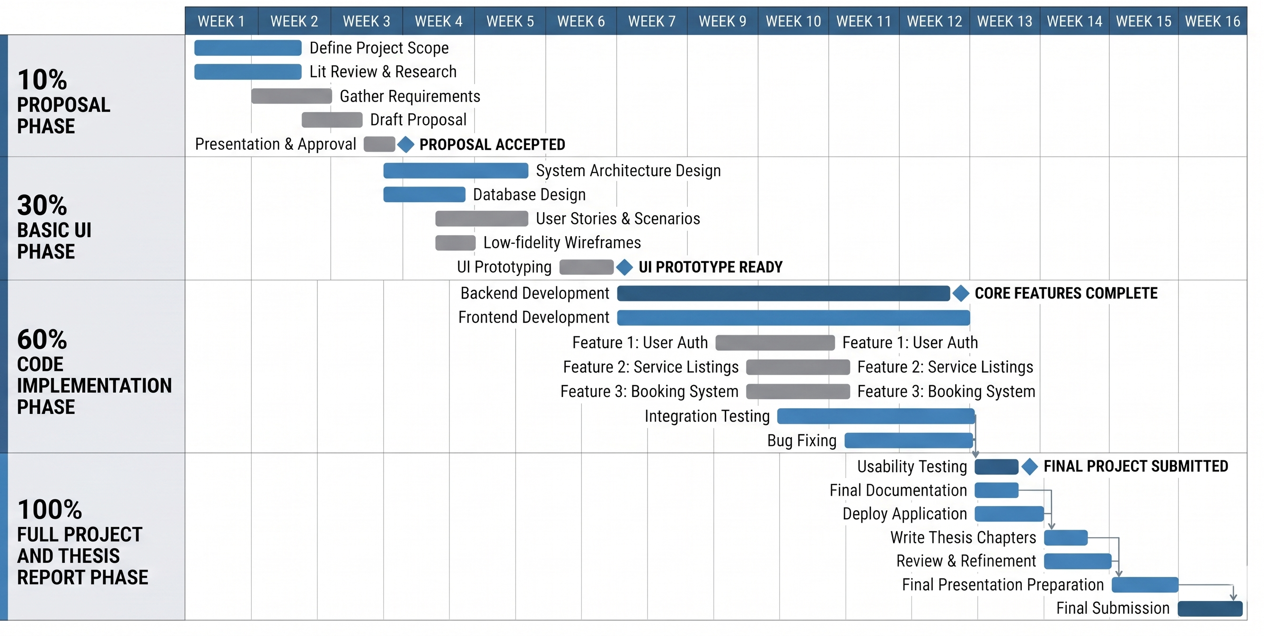

References
Ian Sommerville, Software Engineering, 10th Edition, Pearson Education, 2015.
Roger S. Pressman and Bruce R. Maxim, Software Engineering: A Practitioner’s Approach, 9th Edition, McGraw Hill, 2019.
Flutter Documentation: https://docs.flutter.dev/
Supabase Documentation: https://supabase.com/docs
PostgreSQL Documentation: https://www.postgresql.org/docs/
MDN Web Docs, REST APIs: https://developer.mozilla.org/
Urban Company / UrbanClap related service model.
Care.com related service model.
Handy related service model.

